VIRIDIS : *Dapp for recycling value chain*

**Problem statement**

How can the Cardano community incentivize recycling and enhance individual collectors' income using Tokens and Smart Contracts?

**Our Solution**

How can the Cardano community incentivize recycling and enhance individual collectors' income using Tokens and Smart Contracts?

**Keywords**

Dapp, Recycling, Tokenization, Supply Chain, rPET, Circular Economy, Cardano, Blockchain

1. Introduction

Business and individual entrepreneurs were first leveraging blockchain technologies to enhance their operations and grow their businesses. Next step, Non-profits may embrace the DAO 'proposition' as soon as pioneer projects and infrastructure mature. Our proposal aims to explore a sustainable business model and practical implementation of a DApp on Cardano that incentivize individual and collective collectors/recyclers by providing liquidity and enforcing traceability of recycled materials.

Why plastic recycling?

Every hour, an estimated 2.5 million plastic bottles are thrown. For a single 8oz water bottle, we generate a minimum of 60g of CO2 for producing the raw material (from fossil fuels). By recycling a bottle, we reduce potential emissions by the double of its weight and avoid more harmful impact of plastic trash on land and oceans. Recycling single usage plastics averts the depletion of natural resources by providing sustainable raw plastics to the market.

Many studies point that [lack of] recycling is not a technical issue, but more a result of inefficient supply chains and discouraged collectors and recyclers for not been able to capture the fair value of their labor. Moreover, challengers to the status-ko lack working capital needed. Another important fact is that a significant percentage of collected plastic ends in landfill any way for profitability and supply chain causes. Many cities adopt a green washing strategy and implement point of collect without preparing the ecosystem that will process and use those recycled materials.

The numbers aren't in our side! we need a committed decentralized community to solve such a global problem. But also, a field network of collectives, NGOs, and small processing facilities to be able to optimize supply chain issues.

Why Cardano?

We are fortunate to be already committed to Cardano community, but what drove us to submit the proposal in Catalyst Fund 7 is our faith in the technical capabilities of the protocol and the empowering open community. The openness to contribution made the hard problem more human. On the technical side, the scientific theoretical grounding and the Marlowe tooling suit will help us prototype and simulate predictable behavior and produce a Proof of Concept (POC) Smart Contract more efficiently.

Africa is lagging behind in recycling. Yet, we are persuaded that the much-needed social innovations have the ground to evolve here. This conviction is corroborated by the strategic orientation of Cardano toward Africa, thus encouraging us to build our initiative inside the Catalyst house.

We are looking actively for motivated team members. We encourage everyone to join Viridis and make direct impact! We look for a Cardano Blockchain specialist, accountant, and motivated team members from Catalyst community.

1. A picture containing text

   Description automatically generatedSolution Design

Two tokens

*UPB.* Used Plastic Bottle represents a collected single usage plastic bottle issued as a native asset on Cardano. It is a digital representation of an 8 oz used water bottle (weight approximately 30g). This token is inflationist as it'll track an increasing number of collected then recycled single use plastics bottles.

***Viridis***. The governance token rewards verifiably recycling 100 UPB. Viridis aims to incentivize recycling and to be used as a collateral for Smart Contract execution and liquidity. Hopefully, trough listing on DEXs and free market mechanism, the price will reflect the monetary value given by the community to recycling of 3kg of plastics.

The Smart Contract

The Smart Contract has three main functions, namely, Proof of Collect, Proof of Recycling, Incentives distribution. The on-chain code interacts with aggregators of collected wastes, recyclers, liquidity providers and auditors. Auditors that verify evidence on the ground are incentivized to timely check the on-chain transaction.

We conducted an analysis of building blocks and tools to deliver on the Cardano blockchain. Moreover, we plan to validate the economic soundness through modeling and simulation of the system dynamics using Cadcad toolkit. Marlowe toolkit will be used extensively in prototyping the smart contract. We assume that using Marlowe will shorten our security certification Level 1.

This system aims to provide liquidity to a P2P ecosystem that track and verify origin of recycled wastes. Hence, incentivizing the adoption while enhancing profitability of recycling at grassroot level. We aim to add value to the value chain to benefit all parties.

Walking through the process



collect plastic bottles from streets or facilities

buy plastics from collectors and sell them to processing facilities

sells raw recycled plastic to goods manufacturers

RECYCLERS

COLLECTORS

AGGREGATORS

DISTRIBUTORS

GOODS MANUFACTURERS

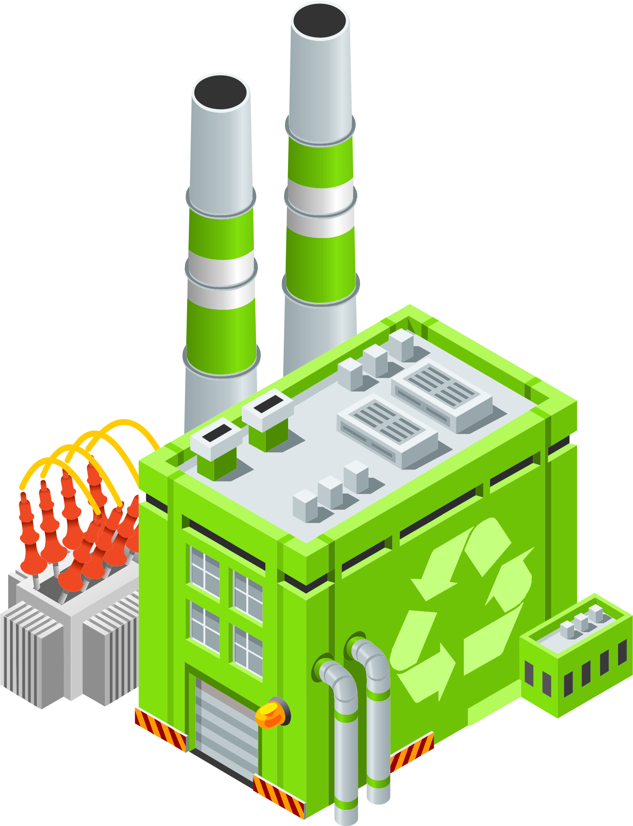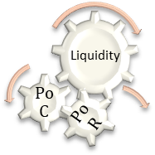

* Individuals, households, or professionals collect and sort plastic bottles
* Collectors sells those plastic wastes to Aggregators
* The Aggregator (Agg) document quantities and localization, upload proofs to IPFS then submit a transaction to the Smart Contract with Viridis tokens as collateral (Proof of collect)
* The Smart contract send an equivalent quantity of UPB tokens to the Aggregator.
* Agg. Sells sorted plastic wastes to a Recycler along with the UPB tokens
* Recyclers process the plastic and produce raw materials or goods and document quantities, upload proofs to IPFS then submit a transaction to the Smart Contract with equivalent UPB tokens (Proof of recycling)
* The Smart Contract unlock collateral and send recycling rewards to participants

In partnership with Carbon offset projects, we plan to issue equivalent Carbon Credit offset by our activities and mint NFTs to extract more value that will be used to incentivize recyclers and, to fund sustainability initiatives.

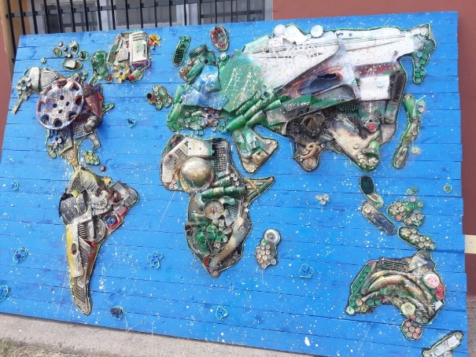

Example of Trash’Art made by our partner “Friends of Nature” for rural school in Morocco

What success looks like?

Success means for us creating value for the Cardano community through the experiment of building a Dapp that has social, economic, and environmental impact. Practically, for the foreseeable future, success lays on delivering the intermediary goals listed underneath:

* Launching a Dapp as a proof-of-concept in 2022
* Minimal bugs and vulnerabilities
* Security Audit for Level 1 certification in 2022
* Reaching Cardano DAO Level 3 in one year
* Open-source release for the Smart Contract and Off-chain code
* Publish a peer reviewed research paper on the economic model and initials findings
* Healthy distribution of the governance token and adoption of state-of-the-art governance rules and tools

1. Working Plan

The realization of the project objectives can be achieved only by meaningful work executed by the project team, our partners, and the community, on an agreed upon plan. For better coordination and auditability, we organized project activities in six work packages.

Work packages

* WP1: Modeling and Prototyping
* WP2: System development, deployment, and continuous improvement
* WP3: Driving Adoption/marketing/community management
* WP4: Growing a network of collectors, recyclers, and users
* WP4: Security and auditability
* WP5: Leveraging Cardano's DeFi ecosystem: particularly DEXs and Launchpads, and other Dapps
* WP6: Governance and Open accounting

Deliverables

* D1: Audited Smart Contract
* D2: A network of collectors and recyclers submitting transactions on Cardano
* D3: Web/mobile User Interface
* D4: Documentation and users' support
* D5: Peer reviewed research paper and lessons learned shared with the community

Milestones

In the first 3 months, we aim to design and prototype a DAO for incentivizing plastic bottles recycling. This first stage we'll work on collaboration and partnerships in parallel of tweaking and enhancing our system design. By the 6th month, we aim to facilitate the recycling of up to 100 000 plastic bottles in an African country (Morocco, Ethiopia or Egypt). And then grow organically through the continent.

And by the end of the year, we target the symbolic number of 1 000 000 bottles (6 tons of CO2 emissions and significant environmental impacts avoided). This will make the Cardano ecosystem more carbon neutral and more eco-friendly.

*6 months*

* Alpha version of the Smart Contract on the Testnet
* Working on level 1 certified Smart Contract
* 100+ registered recyclers and wastes' aggregators
* 100 000 plastic bottles collected

*12 months*

* Public launch
* 1 million recycled bottles by the end of 2022
* 10 000 users
* Capture 50k USD in IDO / ISPO
* Peer reviewed research paper

Technical Feasibility

The proposal team identified essential building blocks and infrastructure on the Cardano blockchain needed to deliver on the project scope.

*Cardano building blocks*

* Marlowe toolkit
* PAB
* Tooling for connecting with DEXs
* Tools for mobile payment
* Tools for DAO governance

1. Stakeholders, Partnerships, and collaborations

Stakeholder identification

*Recycling ecosystem*

* Individual and collective collectors
* Small recycling facilities
* Recycling compagnies
* The plastic industry: Consumers of recycled plastic and producers of raw materials
* Legal and environmental bodies

*Cardano Ecosystem*

* Cardano sustainability initiatives
* Catalyst Community
* Launchpads
* DEXs
* Plutus developers and contracts auditors
* DID for following development stages

Partnerships

* Cardano4Climate: An amazing community that we encourage all to join. C4C is a global community of over 150 members, grown in 3 months that began as a challenge & has turned into a community. https://cardano.ideascale.com/a/dtd/Cardano4Climate-Community-Hub/384081-48088
* Cardano Care: We have many convergent objectives and complementarity with this Fund 7 proposal. https://cardano.ideascale.com/a/dtd/Cardano-Care/382874-48088
* Friends of Nature: Environmental NGO for artistic and technical recycling
* DeFi Carbon Pricing Standard aka BlockCarbon aims to provide Open source toolkit to price and exchange Carbon as tokens. They will be the issuer of Carbon Credit preserved by our activities. https://cardano.ideascale.com/a/dtd/DeFi-Carbon-Pricing-Standard/381939-48088
* Potential: We are open to partnering with relevant projects from current and past Catalyst Fund runs

1. Risk identification

* Technical: bugs & vulnerabilities
* Operational (on the field): Coordination and Supply chain issues, …
* Socio-economic: lack of adoption, high fees, price pressure from fossil fuel sources of plastic…
* Legal: legal uncertainty, conversion between ADA and local currencies…

1. Epilogue

We recognize that digitalization of the informal sector is challenging. Most of the litter collection is performed by the lower economic strata of society: very poor, homeless people and the mentally ill, who slip through or actively avoid engaging in the formal economy and hence are unbanked. Initiating a network that support those vulnerable population by providing them with the fair value of their labor is challenging, yet it is surely worth our effort as a value driven community.

We adhere to the open-source principles, and we give back any Intellectual Propriety Rights to the Cardano community.

1. ACKNOWLEDGMENTS

* Cardano 4 Climate for their support during the draft and refinement phase, and their role as connectors. Big Kudos!
* Prof Sid-Ali Kamel KAYA our senior advisor on the economic model and the game theory aspects of recycling. Prof KAYA have a PhD in economics and published several research papers on public governance, entrepreneurship in emerging markets, but also sustainability and carbon credit related topics.
* The Catalyst Community for their constructive feedback that improved drastically the quality of the first and following drafts.
* The whole Cardano ecosystem for making this possible!